English Reading Curriculum
2025-2026

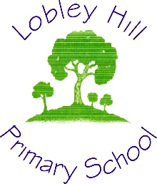

At Lobley Hill Primary School we aim to be the ‘Best that We Can Be’ through being curious, adventurous and respectful in order to achieve personal excellence.

Reading Statement of Intent:
At Lobley Hill Primary School, we believe that reading is a fundamental skill that underpins all areas of learning and personal development. It opens doors to new worlds, ignites imagination, and fosters empathy, curiosity, and understanding. Our intent is to equip every child with the skills, confidence, and enthusiasm to become lifelong readers who can engage with texts both critically and joyfully.
We aim to instil a love of reading from the earliest stages by providing children with a rich and varied reading diet that reflects diverse voices, cultures, and experiences. Our curriculum is carefully designed to build fluency, comprehension, and vocabulary through high-quality teaching of synthetic phonics, guided and shared reading, independent reading opportunities, and the daily enjoyment of hearing texts read aloud.
Reading is embedded across the curriculum. We ensure children encounter a wide range of texts in all subjects, reinforcing the idea that reading is not confined to English lessons but is a vital tool for understanding the world. From fiction to non-fiction, poetry to playscripts, our pupils develop the skills to navigate and appreciate different genres and formats.
We recognise that children thrive when reading is celebrated both in school and at home. That is why we prioritise building strong partnerships with parents and carers, providing them with the tools and confidence to support their child’s reading journey. Through regular communication, workshops, and shared reading initiatives, we work together to foster positive reading habits and attitudes.
At the heart of our approach is the belief that reading for pleasure is key to success—not just academically, but in developing well-rounded, thoughtful individuals. We are committed to nurturing a school culture where reading is visible, valued, and vibrant; where every child has the opportunity to become a fluent, enthusiastic, and independent reader.

Our National Curriculum Says…
“Good comprehension draws from linguistic knowledge (in particular of vocabulary and grammar) and on knowledge of the world. Comprehension skills develop through pupils’ experience of high-quality discussion with the teacher, as well as from reading and discussing a range of stories, poems and non-fiction.”
Rationale for Book Choice
The books that form the whole class reading spine for each year group have been carefully curated and each year group includes:
- Novels/Sustained Stories – this allows the exploration of character development over several chapters and children are guided to move beyond the five-part story.
- High quality picture books – these texts include engaging illustrations that can be used to enhance the reading experience, improve understanding alongside the text and give examples of short stories. It is important to use that the books we share with our children reflet the school community and give children the opportunity to see themselves in the books they read also, we want to expand our children’s awareness of our wider community. The picture books have been chosen to reflect this diversity – BAME, disability, LGBQT, and neuro-diversity.
A traditional tale thread has been built in from year 2 to 6 with children exposed to traditional, twisted and versions from other countries.
- Wordless Fiction – these books require children to ‘read’ and understand the illustrations in order to tell the story. Children will need to use retrieval and inference strategies in order to comprehend well. Progressively challenging books have been planned to be used in each key phase.
- Poetry – each year group has a theme on which their poems are based this ensures that they become familiar with a range of different poetry types and forms.
- Plays – targeted lower key stage two as the key phase to learn about Play Scripts, upper KS2 will use this knowledge to aid in their end of year performances. Progression has been built in to ensure that children are taught how to use the key layout features. The stage direction and vocabulary become more challenging with the second play they encounter.
- Non-Fiction – within this, children will be exposed to a range of different formats including online texts, one-page documents and high-quality non-fiction books. The text types have been carefully balanced across year groups to ensure children experience a range of different genres and topics. Text become increasingly challenging and children are progressively introduced to layout devices and techniques.
Year 2 | Year 3 | Year 3/4 | Year 4 | Year 5 | Year 6
Information | Information | Information | Information | Information | Information
Biography | Letters |  | Explanation | Persuasion | Biography
 |  |  |  | Biography  Speeches | Mix of Non-fiction Past Papers

Teaching in units
We teach in reading units to allow a deeper study of the text and to ensure children are reading whole texts and not just extracts. (The exception to this is in non-fiction where teachers are not expected to start at the beginning of the book and work their way through rather, teaching will focus on use of contents page using specific sections, referring to glossary etc. alongside this double page spreads and online versions of texts will be used.)
Each unit has been allocated a specific amount of time within a half term dependent on the length and complexity of the text.
It is expected that a novel study will include more independent reading time where appropriate. This allows children to develop their pace and stamina for reading. During this time, it is expected that teachers support children who are weaker work readers to access the class text.
Reading lessons
Children in Year 1 follow the full RWI programme for reading and writing. They are groups according to ability and work through the different stages of the programme.
Word time Lessons: As soon as children have learnt a few initial letter sounds they begin to learn to blend the sounds together to read real words in a Word Time session. Each word time session involves oral blending of known sounds before they are shown the words written down on green cards. Children practice Fred talking the words until they become able to read them on sight. Ditty lessons follow on from this where children who are becoming excellent at reading single words are introduced to reading whole sentences.
Storybook Lessons: The next stage of the Read Write Inc scheme is for children to read storybooks that are closely matched to their developing phonic knowledge. The storybooks consist of green words linked to the sounds they have been learning, red words (words that are not decodable) and challenge words to extend children’s vocabulary. After children have practiced these words individually, they are prepared to see them in context in the story. These story books are read a minimum of three times to aid with fluency, comprehension and expression.
Whole class reading lessons
Year 2 marks a transition between the RWI programme and our whole class reading lessons. How this looks in terms of timings year to year will vary dependant on cohort strengths and weaknesses. For example, the cohort starts off the year in guided group reading linked to phonic texts and then transitions to whole class reading, the timing of this will vary year on year and teacher assessment will determine when this transition takes place.
Children from Year 3-6 have daily 30 minute whole class reading lessons. The aim of whole class reading lesson is to develop the knowledge needed to understand increasingly challenging texts. We aim to guide and support children to become better at drawing meaning from a text:
- Develop children’s knowledge of the world
- Build breadth and depth in vocabulary knowledge
- Teach and scaffold the application of comprehension strategies
- Explore grammatical relationships (develop knowledge of syntax: word order, use of pronouns and sentence structure)
- Develop knowledge of text structure

Lessons are structured to ensure that learning is scaffolded through the following key elements:
Retrieve | Orientate | Read | Explicit Teaching | Explore and Explain
Revisit Previous Learning  e.g.  -Summary of the story so far. (Who, what, why, when, where, how)  -Revisit Key Vocabulary  -Tell me three things about… | Ensure that children have the necessary background knowledge  e.g.  -Activate background knowledge  -Share key information  -Preview vocabulary | Read aloud and to themselves e.g.  -Model fluent reading  -Echo read  -Choral read  -Re-read to themselves  -Read a section/chapter to move forward in the plot | Explicit Teaching: including modelling and demonstrating e.g.  -Model a strategy  -Teach vocabulary  -Talk aloud  -Demonstrate how to complete a task | High quality discussion with opportunity think, question, discuss and explain in order to deepen understanding e.g.  -Book talk  -Think-pair-share  -Group discussion  -Group tasks  -Drama
Please note that retrieval and orientation should be delivered at the start of every lesson. However, read, teach and explore may follow a more flexible approach and should be delivered as appropriate to the sequence of learning.
Scaffolding for lower attainers
All children should access the whole class reading lessons in line with National Curriculum guidance. The National Curriculum states that in Year 3 and 4:
‘As far as possible these pupils should follow the year 3 and 4 programme of study in terms of listening to new books, hearing and learning new vocabulary and grammatical structures, and discussing these.’
In Years 5 and 6:
‘As far as possible, these pupils should follow the upper key stage 2 programme of study in terms of listening to books and other writing that they have not come across before, hearing and learning new vocabulary and grammatical structures, and having a chance to talk about all of these.’
Word reading and fluency for these children is addressed through:
- Afternoon phonics intervention
- Daily reading with teacher or teaching assistant
Within whole class reading lessons, lower attainers should be supported by a Teaching assistant (if available) to model use of vocabulary, aid in discussions, re-read texts as needed.
Planning expectations
Planning for each unit is completed on a weekly basis using the criteria set out previously: retrieve, orientate, read, explicit teaching and explore and explain. A blank copy of this plan can be found on the school server. (2023-2024, Curriculum, English). Brief assessment notes and observations for feed forward should be made as appropriate to ensure the lessons meet the needs of all children. These will them inform end of term assessments.
Recording expectations
In Lobley Hill Primary School, we expect the majority of lessons to be centred around high-quality discussion and explicit teaching of reading. There may be occasion where recording is beneficial to the children:
a. tasks that support understanding of the text. E.g., ranking character traits, using vocabulary in context, sorting vocabulary.
b. tasks that support teacher assessment.
One such example of this is a weekly SATs style question relating to the text being studied. A rage of different style questions should be covered through the year. (Formats for these questions can be found on the school server.)
Assessment
At Lobley Hill Primary school we follow the Gateshead Gap for assessment. All formative assessments are noted in each lesson, these then inform the formative assessment tracker (Appendix 1) which is to be filled in at the end of each term.
At three points during the year, the end of each term, children from years 3 – 6 will have a standardised reading assessment. We use the NFER reading assessments. These results will then be collated and evaluated to ensure any weaknesses across individuals or year groups can be targeted the following term.
Within Year 6 we use SATs past papers at the end of each term (2023, 2022, 2021) in the same way at 3 points during the year.

Appendix 1

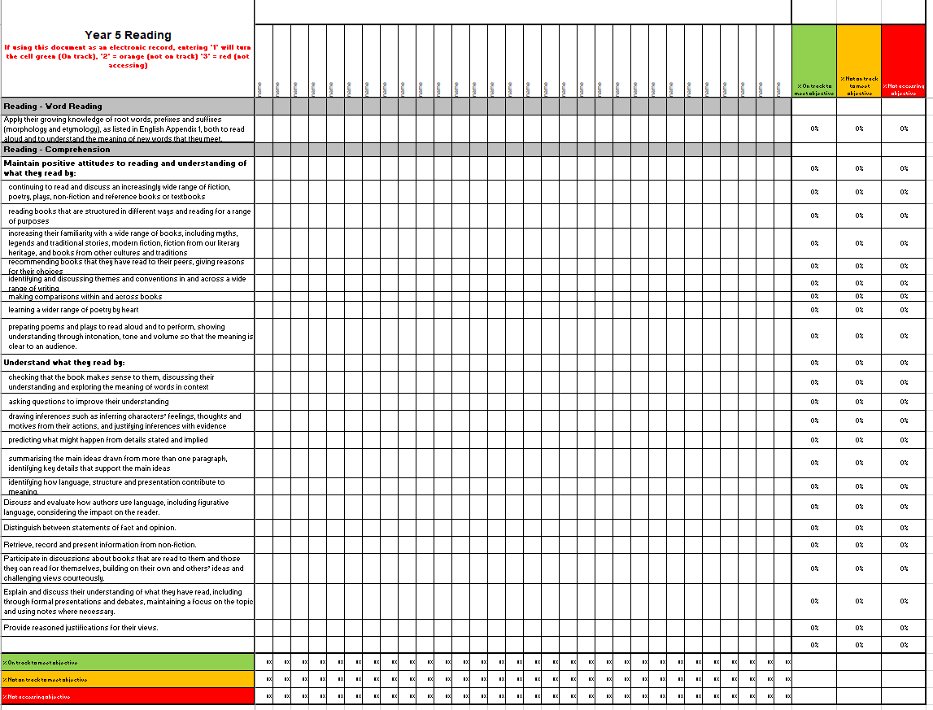

 | Reading Annual overview
 | Core texts covered over the course of the year
Nursery | The Last Noo-Noo By Jill Murphy | We’re going on a Bear Hunt by Michael Rosen | Rabbit’s Pancake Picnic By Teagan Evans and Paula Bowles | The Three Little Pigs – traditional version | Farmer Duck By Martain Waddell | The Very Hungry Caterpillar by Eric Carle | Puddling By Emma Perry | The Gingerbread Man – Traditional Version | Dear Zoo by Eric Carle | All Kinds of People by Emma Damon | Is it larger? Is it smaller? by Tana Hoban | Ten Black Dots by Donald Crew
Reception | Once Their Were Giants by Martain Waddell | After the Storm by Nick Butterworth | Supertato by Sue Hendra and Paul Linnett | Goldilocks and the three Nears – Traditional Version | Monkey Puzzle by Julia Donaldson | Marvellous Me by Lisa Bullard | And Tango Makes Three by Justin Richardson | Dogger by Shirley Hughes | Out and About a collection of poems by Shirley Hughes | Shapes, Shapes, Shapes by Tana Hoban | Cubes, Cones, Cylinders, Spheres by Tana Hoban | 1 to 20 Animals Aplenty  by Katie Viggers
Year 1 | Little Red Riding Hood – Traditional version | Jack and the Beanstalk – traditional version | The Jolly Postman by Allan Ahlberg | Billy and the Beast by Nadia Shireen | The Snail and the Whale by Julia Donaldson | Roby’s Worry by Tom Percival | The Magic Porridge Pot – traditional version | The Highway Rat by Julia Donaldson | Poems Out Loud!: First Poems to Read and Perform

 | Autumn 1  8 weeks | Autumn 2  7 weeks | Spring 1  7 weeks | Spring 2  5 weeks | Summer 1  5 weeks | Summer 2  7 weeks
Year 2 | No Dinner by Jessica Souhami (2 Weeks) | Chalk by Bill Thomson (1 Week) | I don’t like snakes by Nichola Davies (2 Weeks) | The Hodgeheg by Anne Fine (4 Weeks) | The Big Book of Blooms by Yuval Zommer (3 Weeks) | Twits by Roald Dahl (5 Weeks)
Year 2 | The Sun, Moon and Stars –Scholastic  Wild Dogs by Lynette Evans (2 Weeks) | Poetry: The Puffin Book of Fantastic First Poems (3 Weeks) | Little People Big Dreams Marcus Rashford (2 Weeks) | The Hodgeheg by Anne Fine (4 Weeks) | The Big Book of Blooms by Yuval Zommer (3 Weeks) | Twits by Roald Dahl (5 Weeks)
Year 2 | Rapunzel by Sarah Gibb (2 Weeks) | The Santa Trap by Jonathan Emmett (2 Weeks) | Big Bo Peep by Jonathan Allen (2 Weeks) | The Hodgeheg by Anne Fine (4 Weeks) | Invisible by Tom Percivle (2 Weeks) | Twits by Roald Dahl (5 Weeks)
Year 2 | Rapunzel by Sarah Gibb (2 Weeks) | Summative assessment (1 Week) | Big Bo Peep by Jonathan Allen (2 Weeks) | Summative assessment (1 Week) | Invisible by Tom Percivle (2 Weeks) | Summative assessment (1 Week)
Year 3 | Survival Guide by David Orme (3 Weeks) | Clown by Quentin Blake (1Week) | How to Train Your Dragon by Crassida Cowel (6 Weeks) | How to Train Your Dragon by Crassida Cowel (4 Weeks) | Catkin by Antonia Barber (2 Weeks) | DK Find Out Robots 3 Weeks)
Year 3 | Survival Guide by David Orme (3 Weeks) | Poetry: Hot like Fire by Valerie Bloom (3 Weeks) | How to Train Your Dragon by Crassida Cowel (6 Weeks) | How to Train Your Dragon by Crassida Cowel (4 Weeks) | Until I met Dudley by Rodger McGough (3 Weeks) | A magic Medicine It Shall Be – Play (1 Week)
Year 3 | Nen and the Lonely Fisherman by Ian Eagleton and Little Mermaid traditional story (3 Weeks) | The Christmasaurus Picture book by Tom Fletcher (supported by use of description from novel version) (2 Weeks) | How to Train Your Dragon by Crassida Cowel (6 Weeks) | How to Train Your Dragon by Crassida Cowel (4 Weeks) | Until I met Dudley by Rodger McGough (3 Weeks) | The Dot – Play (1 Weeks)
Year 3 |  | Summative assessment (1 Week) | How to Train Your Dragon by Crassida Cowel (6 Weeks) | Summative assessment (1 Week) | Until I met Dudley by Rodger McGough (3 Weeks) | Summative assessment (1 Week)
Year 3/4/5/6 | Turn that Light out by Ken Adey (3 Weeks) | The Pencil by Alan Ahlberg (1Week) | Flat Stanley by Jeff Brown | Big Blue Whale by Nichola Davies (2 Weeks) | Omnibombulator by Dick King-Smith  (5 Weeks) | DK Find out – Arctic and Antartic (3 Weeks)
Year 3/4/5/6 | Turn that Light out by Ken Adey (3 Weeks) | Poetry: The very best of Richard Edwards (3 Weeks) | Flat Stanley by Jeff Brown | Big Blue Whale by Nichola Davies (2 Weeks) | Omnibombulator by Dick King-Smith  (5 Weeks) | Fantastic Mr Fox – Play (2 Weeks)
 |  |  |  | Project Science - Insects (2 Weeks) | Omnibombulator by Dick King-Smith  (5 Weeks) | Fantastic Mr Fox – Play (2 Weeks)
Year 3/4/5/6 | Voices in the Park Anthony Browne (3 Weeks) | The Christmas Eve Tree by Deliah Huddy (2 Weeks)
 |  |  |  | Summative assessment (1 Week) | Omnibombulator by Dick King-Smith  (5 Weeks) | Fantastic Mr Fox – Play (2 Weeks)
Year 3/4/5/6 | Voices in the Park Anthony Browne (3 Weeks) | Summative assessment (1 Week) | Flat Stanley by Jeff Brown | Summative assessment (1 Week) | Omnibombulator by Dick King-Smith  (5 Weeks) | Summative assessment (1 Week)
Year 3/4 and Year 4 | The Magpie Song by Laurence Annholt (3 Weeks) | Window by Gennie Baker (1 Weeks) | The Witches by Roald Dahl (6 Weeks) | Granny came here on the empire Windrush(2 Weeks) https://online.flipbuilder.com/nosycrow/hgbr/#p=38 | Varjak Paw by S.F.Said (5 Weeks) | DK Find out Science (3 Weeks)
Year 3/4 and Year 4 | The Magpie Song by Laurence Annholt (3 Weeks) | Poetry: A Nest Full of Stars written by James Berry (3 Weeks) | The Witches by Roald Dahl (6 Weeks) | How does Chocolate taste on Everest? (2 Weeks) | Varjak Paw by S.F.Said (5 Weeks) | Egyptian Cinderella Play – Play (1 Weeks)
Year 3/4 and Year 4 | Nail Soup by Eric Maddern (3 Weeks) | The Christmas Miracle of Jonathan Toomey by Susan Wojciechowski (2 Weeks) | The Witches by Roald Dahl (6 Weeks) | How does Chocolate taste on Everest? (2 Weeks) | Varjak Paw by S.F.Said (5 Weeks) | Macbeth– Play (1 Weeks)
Year 3/4 and Year 4 | Nail Soup by Eric Maddern (3 Weeks) | Summative assessment (1 Week) | The Witches by Roald Dahl (6 Weeks) | Summative assessment (1 Week) | Varjak Paw by S.F.Said (5 Weeks) | Summative assessment (1 Week)

 | Autumn 1  8 weeks | Autumn 2  7 weeks | Spring 1  6 weeks | Spring 2  5 weeks | Summer 1  6 weeks | Summer 2  7 weeks
Year 5 | Bears, Cannons and Trumpets: Why Shakespear’s Theatre was the best by Catherine Allison  Linked to online theatre promotion and leaflets (3 Weeks) | Tuesday by David Weisner (1 Week) | The Fire Work Makers Daughter by Phillip Pullman (6 Weeks) | Space Exploration Eye Witness (2 Weeks) | The Nowhere Emporium by Ross Mckenzie (5 Weeks) | Young Women who make a difference  Little people big dreams Greta Thunberg  No one is too small to make a difference speeches  Little People Big Dreams Malala Yousafzai (5 Weeks)
Year 5 |  | Poetry: The Highwayman by Alfred Noyes (3 Weeks)
 |  |  |  | The Wolf’s Secret By Myriam Dahman (2 Weeks) | The Nowhere Emporium by Ross Mckenzie (5 Weeks)
Year 5 | I talk like a river by Jordan Scott(3 Weeks) | The Snow Queen by Hans Christian Anderson illustrated by PJ Lynch (2 Weeks)
Year 5 | I talk like a river by Jordan Scott(3 Weeks) | Summative assessment (1 Week) | The Fire Work Makers Daughter by Phillip Pullman (6 Weeks) | Summative assessment (1 Week) | The Nowhere Emporium by Ross Mckenzie (5 Weeks) | Summative assessment (1 Week)
Year 6 | Kensuke’s Kingdom by Michel Mopergo (6 weeks) | Water World by Ben Rothery (2 Weeks) | Past papers (3 Weeks) | Past Papers (2 Weeks) | No Ballet Shoes in Syria by Katherine Bruton (5 Weeks) | The Battle for Equality by David Roberts (3 Weeks)
Year 6 | Kensuke’s Kingdom by Michel Mopergo (6 weeks) | Poetry: Selected Poems for Children by Charles Causley (2 Weeks) | Past papers (3 Weeks) | The Arrival by Shaun Tan (2 Weeks) | No Ballet Shoes in Syria by Katherine Bruton (5 Weeks) | The Battle for Equality by David Roberts (3 Weeks)
Year 6 | Kensuke’s Kingdom by Michel Mopergo (6 weeks) | A Christmas Carol by Tony Mitton (supported by extracts from other versions of the text) (2 Weeks) | Past papers (3 Weeks) | The Arrival by Shaun Tan (2 Weeks) | No Ballet Shoes in Syria by Katherine Bruton (5 Weeks) | The Sleeper and the Spindle by Neil Gammon (2 Weeks)
Year 6 | Kensuke’s Kingdom by Michel Mopergo (6 weeks) |  | Past Papers (3 Weeks) | The Arrival by Shaun Tan (2 Weeks) | No Ballet Shoes in Syria by Katherine Bruton (5 Weeks) | The Sleeper and the Spindle by Neil Gammon (2 Weeks)
Year 6 | Kensuke’s Kingdom by Michel Mopergo (6 weeks) | Summative assessment (1 Week) | Past Papers (3 Weeks) | Summative assessment (1 Week) | No Ballet Shoes in Syria by Katherine Bruton (5 Weeks) | Summative assessment (1 Week)

Novel | Picture Book | Book Without Words | Non-fiction | Assessments | Poetry

